
College of Information and Computing Sciences


Point of sales system

Submitted by:
Karla Mae adap
Francescalei Angoluan

Submitted to:
Albert A.Canlas

Date of submission
August 2025

Table of Contents
1.Introduction ………………………………………...................i
1.1Purpose ……………….……….……………………………….….1
1.2 Scope.……………………………………………………………..2
1.3 Acronyms, and Abbreviations ………………..…………………..3 1.4 Reference …………………………………….…………………...……4
1.5 Overview ………..……………………....………………………..5
2.Functional Data Description…………………………………ii
2.1 Data Overview…………………………………………………….6
2.2 Data Structures…………………………………………………….7
2.3 Data Flow………………………………………………………….8
2.4 Data Storage……………………………………………………….9
3.Subsystem Description………………………………………..iii
3.1 Subsystem Overview……………………………………………..10
3.2 Subsystem 1: [Subsystem Name]…………....................................11
3.3 Subsystem 2: [Subsystem Name]]………………………………...12
3.4 Subsystem N: [Subsystem Name]………………………………...13
4.System Modeling and Simulation Results………………….iiii
4.1 System Model……………………………………………………..14
4.2 Simulation Result…………………...............................................15
5.Products………………………………………………………………..iiiii
5.1 Product Overview………………………………………………...16
5.2 Product 1: [Product Name] .……………………………………...17
5.3 Product 2: [Product Name]……………………………………….18
5.4 Product N: [Product Name]………………………………………19
6.Appendices…………………………………………………iiiiii
6.1 Appendix A: Glossary……………………………………………20
6.2 Appendix B: Reference…………………………………………..21
6.3 Appendix C: Change Log………………………………………...22

1.Introduction
This Software Requirements Specification (SRS) document provides a comprehensive overview of the requirements for the development of a Point of Sale (POS) system. The POS system is intended to facilitate the sale of goods and services by enabling businesses to perform transactions, monitor inventory levels, track sales performance, and generate reports efficiently and accurately.

As modern businesses face increasing demands for faster service and real-time data, the development of a reliable and user-friendly POS system has become essential. This document is aimed at aligning the understanding and expectations of all stakeholders involved in the software development lifecycle. It ensures that developers build a system that reflects the real-world needs of its users, testers verify it according to the defined functionalities, and business owners and managers can depend on it to support daily operations and decision-making.

The SRS defines both functional and non-functional requirements, outlines system features, user roles, and external interfaces, and identifies any constraints or assumptions that may impact development. It serves as a baseline for the system’s design, implementation, and maintenance phases, reducing the risk of misunderstanding ands scope creep throughout the project lifecycle.

1.1Purpose
The primary purpose of this document is to clearly outline the software requirements for the POS system. It acts as a formal agreement between the client, development team, and other stakeholders, ensuring that everyone has a mutual understanding of the system’s goals and expectations.

This POS system is designed to streamline business operations by automating sales transactions, providing inventory control, managing customer and employee data, and generating insightful sales and financial reports. The system is intended to be scalable, supporting single or multi-branch establishments such as retail stores, restaurants, and service-based businesses.

1.2 Scope
The POS system will allow businesses to manage sales transactions efficiently. It will include functionalities such as product management, inventory tracking, sales processing, and reporting. The system will support multiple user roles, including cashiers, managers, and administrators. Features such as employee login, receipt generation, and real-time sales reporting will be included. It will not cover external accounting software integration in this version.
1.3 Definitions, Acronyms, and Abbreviations

POS: Point of Sale
SKU: Stock Keeping Unit
GUI: Graphical User Interface
DBMS: Database Management
VAT: Value-Added Tax
UI: User Interface
API: Application Programming Interface

1.4 References
- IEEE Standard 830-1998 for Software Requirements Specifications
- Company Inventory Policy Document
- Related User Interface Design Documents

1.5 Overview

The Point of Sale (POS) System is designed to streamline retail and business transactions by integrating sales processing, inventory management, user accounts, and reporting features into one unified platform.

Sales Processing – Records transactions, processes payments, and generates receipts in real time.
Inventory Management – Tracks product quantities, updates stock levels after each sale and manages pricing details.
User Accounts – Manages staff access with different permission levels to ensure system security.
Reporting – Creates detailed sales, inventory, and performance reports for business analysis.

2. functional data

2.1Data Overview
By leveraging the data captured by a POS system, businesses can gain a deeper understanding of their operations and make informed decisions to drive success. Point of Sale (POS) system captures and stores a wide range of data, including:

Sales Data: Transaction records, sales amounts, dates, and times
Product Data: Product information, inventory levels, and sales trends
Customer Data: Customer information, purchase history, and loyalty program details
Employee Data: Employee information, sales records, and access controls
Payment Data: Payment method records, such as credit card information (securely stored)

2.2Data structures

Data type | Description | Format
User Information | Stores name, username, role | String, Email
Transaction Records | Tracks sales with date, amount, items | Numeric, DateTime
Inventory Data | Product details and stock levels | String, Integer
Customer Data | Name, contact info, purchase history | String, Phone, DateTime

2.3 Data flow
Imagine a well-oiled machine, where every piece of data flows seamlessly from one stage to the next. That’s what a Point of Sale (POS) system’s data flow is all about. It’s the backbone of your business, enabling you to capture, process, store, transmit, and analyze data with ease.

The Journey of Data

Data Capture: It all starts here. Sales data is captured through various input methods, such as barcode scanners, touch screens, or keyboards. This is where the magic begins, and your POS system starts to gather valuable insights.

Data Processing: The captured data is processed by the POS system, which calculates totals, applies discounts, and updates inventory levels. This stage is crucial, as it ensures that your data is accurate and up-to-date.

Data Storage: The processed data is stored in a database, either locally or in the cloud, for future analysis and reporting. This is where your data is safely kept, ready to be retrieved and analyzed whenever you need it.

Data Transmission: Data is transmitted to other systems, such as inventory management, accounting, or customer relationship management (CRM) systems. This stage enables you to integrate your POS system with other business applications, creating a seamless experience.

Data Analysis: The stored data is analyzed to provide insights into sales trends, customer behavior, and inventory levels. This is where the real magic happens, and you can use data to inform business decisions and drive growth.

Streamline Operations: Automate sales, inventory, and customer management processes, reducing manual errors and increasing efficiency.

Improve Accuracy: Ensure that data is accurate and up-to-date, reducing discrepancies and errors.

Gain Insights: Analyze sales trends, customer behavior, and inventory levels to inform business decisions and drive growth.

Make Data-Driven Decisions: Use data to optimize business strategies, improve customer satisfaction, and increase revenue.

In short, a POS system’s data flow is the lifeblood of your business, enabling you to make informed decisions, optimize operations, and drive growth. By understanding how data flows through your POS system, you can unlock its full potential and take your business to new heights.

2.4 Data storage
A Point of Sale (POS) system is a treasure trove of business data, storing vital information that helps you run your operations smoothly. At its core, a POS system stores:

Sales Data: Every transaction, sale, and product detail
Inventory Data: Product information, stock levels, and supplier details
Customer Data: Customer information, purchase history, and loyalty program details
Employee Data: Employee information, sales records, and access controls
Payment Data: Securely stored payment method records

This data is typically stored in a database, either locally or in the cloud, and is used to:

Track Sales: Monitor sales trends, peak hours, and product performance
Manage Inventory: Keep tabs on stock levels, automate reordering, and optimize inventory
Analyze Customer Behavior: Understand customer preferences, purchase history, and loyalty program engagement
Optimize Operations: Make data-driven decisions to improve business performance and efficiency

By storing and analyzing this data, a POS system helps businesses like yours make informed decisions, drive growth, and stay ahead of the competition. With a POS system, you can unlock valuable insights into your business and take it to the next level.

3. Subsystem Description

3.1 Subsystem overview
The POS system will be divided into multiple subsystems to manage complexity. These include sales processing, inventory control, user management, reporting, and hardware interface. Each subsystem contributes to the system’s overall functionality.

3.2 Subsystem 1: Sales Processing

This subsystem manages all real-time transaction operations. It supports barcode scanning, cart creation, discount application, total calculation, and receipt generation. It also supports different payment methods (cash, card, mobile payments) and ensures that each transaction is securely logged.

3.3Subsystem 2: Inventory Management
The Inventory Management subsystem tracks the stock levels of products. When items are sold, the inventory is automatically adjusted. Admin users can also manually add or remove items, generate stock reports, and set low-stock thresholds that trigger restocking alerts.

3.4 Subsystem 3: User Authentication
This subsystem is responsible for managing user logins and access control. It verifies credentials, assigns roles, and maintains user sessions. It restricts sensitive actions (like modifying prices or deleting records) to authorized users only.

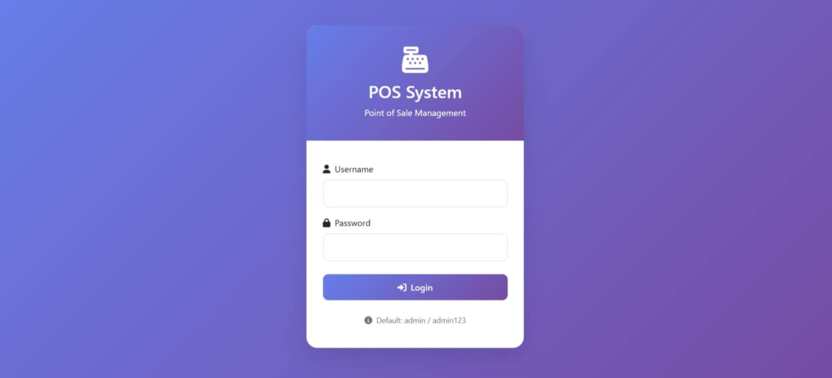

3.5 Subsystem 4: Reporting
The Reporting subsystem aggregates and displays historical sales data, user activity, and inventory changes. It generates daily, weekly, and monthly reports to aid business analysis. Reports can be exported in standard formats such as PDF or Excel for external review.
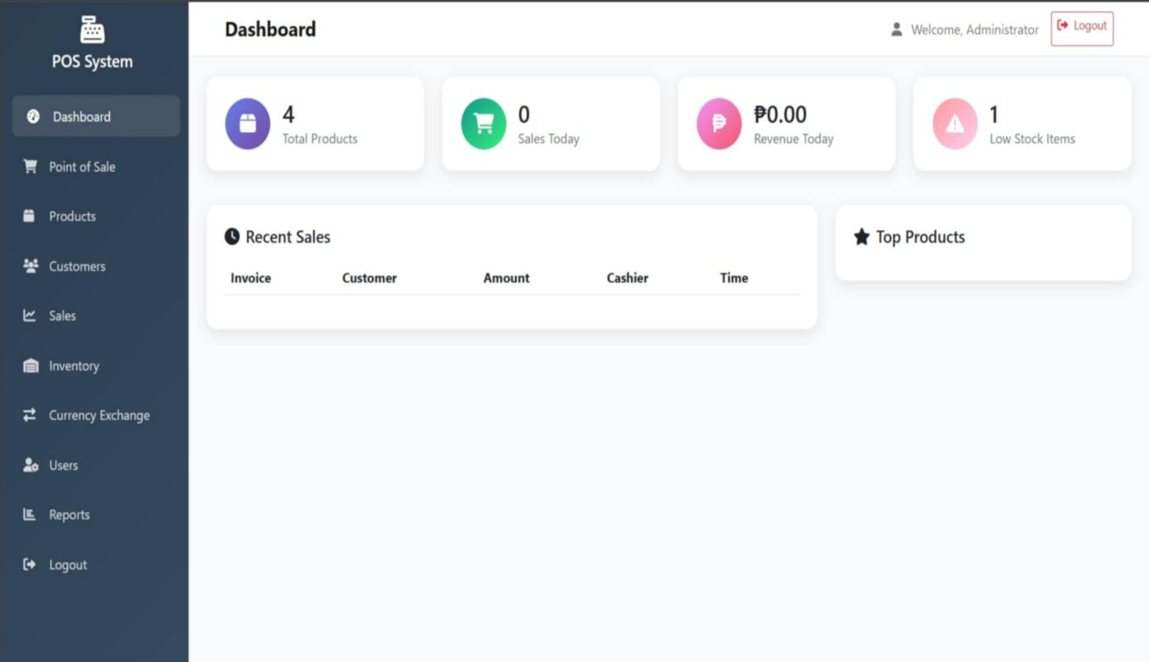

4. System Modeling and Simulation Results

4.1 System Model

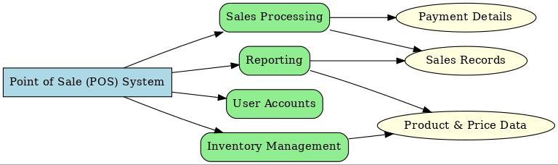

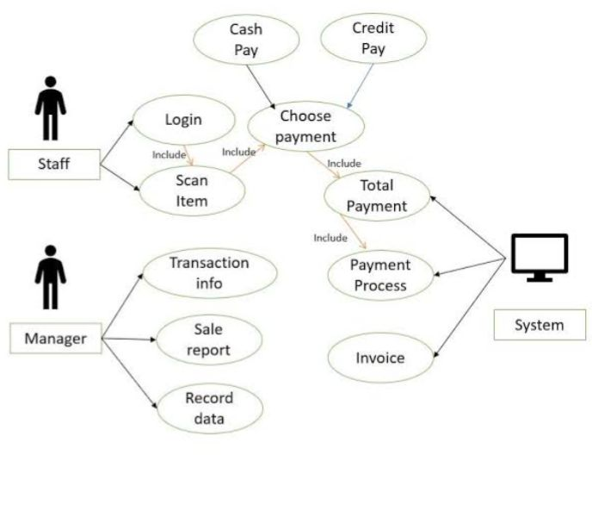
4.2Simulation Result

5. Products

5.1 Product Overview:
The deliverables include the main POS software application, database schema, user manuals, training materials, and system documentation. Each product will be delivered in stages aligned with development milestones.

5.2 Product 1: POS Software Application
Includes the UI, backend logic, integration APIs, and reporting tools. Built using modern frameworks for performance and scalability.

5.3 Product 2: Centralized Database System
Includes schema definitions, stored procedures, triggers, and backup protocols. Designed to ensure data integrity and support concurrent access.

5.4 Product 3: User and Technical Documentation
Covers system usage instructions, troubleshooting guides, setup procedures, and system architecture overviews.

5.5 Product 4: Training Materials
Training slides, videos, and hands-on exercises for store staff and IT administrators.
6.Appendices

The appendices of a Point of Sale (POS) system typically include additional features and functionalities that support the main POS system.

Inventory Management: Tracks stock levels, monitors inventory movement, and generates reports on stock levels and product sales.

Customer Relationship Management (CRM): Stores customer information, tracks purchase history, and enables personalized marketing and loyalty programs.

Reporting and Analytics: Generates reports on sales, inventory, customer behavior, and other key performance indicators (KPIs).

Employee Management: Tracks employee hours, sales performance, and other metrics, enabling better management of staff.

Payment Processing: Integrates with various payment gateways, enabling secure and efficient payment processing.

Online Ordering and Delivery Integration: Integrates with online ordering systems, enabling seamless management of online orders and delivery logistics.

Loyalty and Rewards Program: Tracks customer loyalty points, rewards, and redemption, enabling businesses to incentivize repeat customers.

Gift Card Management: Manages gift card sales, redemption, and balances, enabling businesses to offer gift cards to customers.

Time Clock and Scheduling: Tracks employee hours, schedules, and attendance, enabling better management of staff.

Integration with Other Systems: Integrates with other business systems, such as accounting software, enabling seamless data exchange and reducing manual errors.

These appendices can enhance the functionality and effectiveness of a POS system, enabling businesses to streamline operations, improve customer satisfaction, and increase revenue.

6.1.Appendix A: Glossary

Barcode Scanner: A device that scans barcodes on products to quickly identify and price them.

Cash Drawer: A secure container that stores cash and coins, often integrated with the POS system.

Customer Display: A screen that displays transaction information to the customer.

Inventory Management: The process of tracking and managing stock levels, often integrated with the POS system.

Payment Gateway: A secure system that processes credit card and other electronic payments.

Point of Sale (POS) Terminal: The hardware and software combination that enables transactions to be processed.

Product Lookup (PLU): A code used to identify specific products, often used for produce or other items without barcodes.

Receipt Printer: A device that prints receipts for customers.

SKU (Stock-Keeping Unit): A unique identifier for each product in the inventory.

Transaction: A single purchase or exchange of goods or services.

User Interface: The software component of the POS system that allows users to interact with the system.

Card Reader: A device that reads credit or debit cards for payment processing.

These terms are commonly used in the context of POS systems and can help you understand the technology and its applications.

6.2 Appendix B: Reference

Glossary-moldstud.com
Change log- alexandria.com
6.3 Appendix C: Change log
F1 – Tender
F2 – Clear All
F3 – Print Last Invoice
F4 – Log-Out
F5 – Cash
F6 – Charge
F7 – Check
F8 – Multiple Funding
F9 – Gift Receipt

